WHEELIE App Case

2011-2013

Lorenzo Reyes

Wheelie Wonka case offers a data set of bike users trips taken from 2011 August to 2013 November, with data types to identify and analyses how the users made their travels.

At the beginning we check the accuracy of the information, as timestamps weren’t in order and some travels ended in negative duration. After proper formatting of records, we needed to identify routes, in two levels by stations and municipalities, as to be able to identify in what cities there were more active users, having 94% of the activity performed in Boston, Cambridge and Boston-Cambridge. After applying a dictionary counter of routes, we multiply each path with it mean duration and build a weighted average per trip, with 20 minutes being the average duration of a trip.

In the same line, we can observe an increase of users activity by 6 times (788 trips to 4817, from 2011 to 2013). As we can see the growth measured in the monthly average of trips:

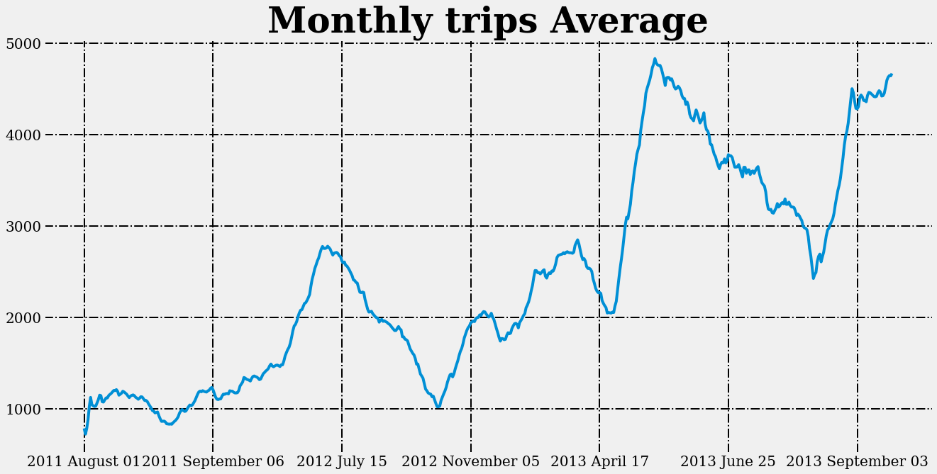

Nonetheless, this increased activity didn’t mean that the stock of bikes available were in danger, in sense a user that wants to make a travel does not find an available bike. In fact the ratio bike per user is 2.19. This data is shown by the daily occupancy of bikes and users activity shows us:

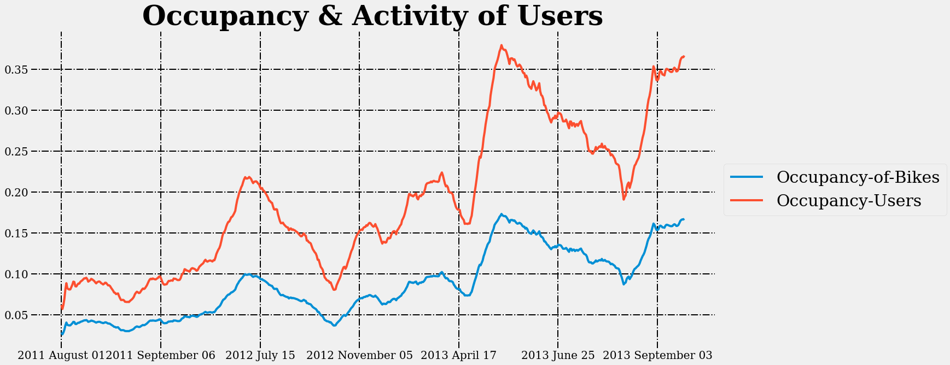This results are made by dividing the quantity of trips given the number of bikes and users. There had not been stress situations for the app, we assumed a duration of an hour per trip to exaggerate actual case, in order to stress the availability of bikes. However if we assume a continuous growth of the same nature, without acquiring new bikes, in two years problems of availability will start to arise.

Another point to remark is the time distribution per hours, to now which hours are of more activity in the day:

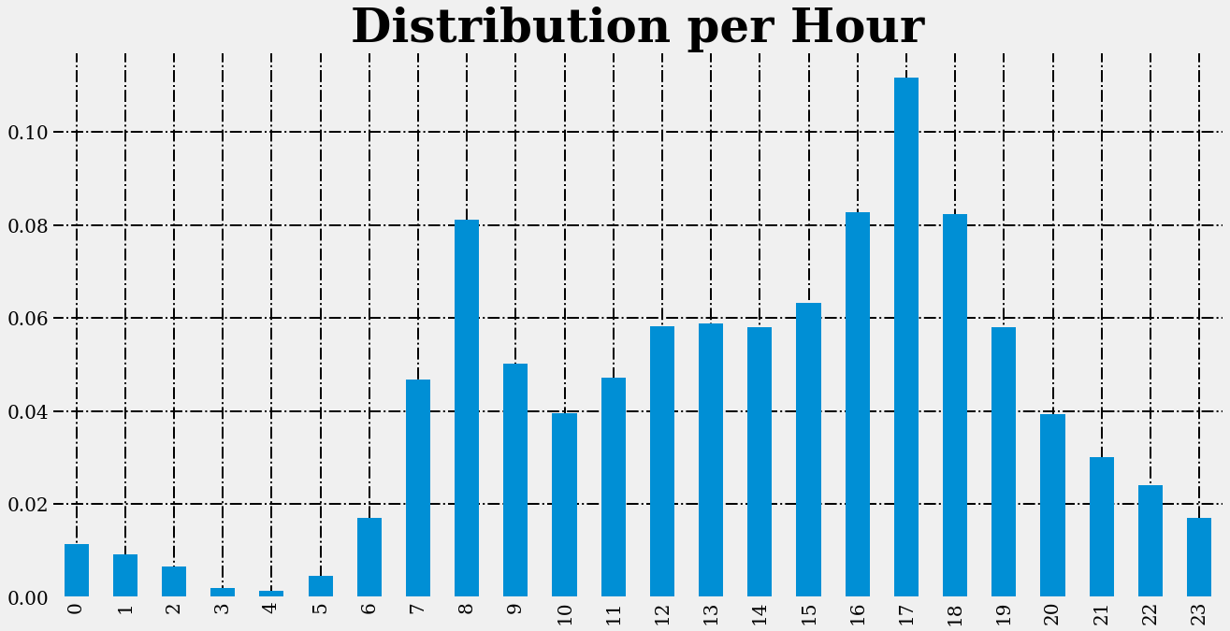The distributions shows two peaks at 8 and 17 hours, during those hours the activiy concentrates, following a tendency of working hours from 8 am. to 5 pm. Unlike the hours distribution, there isn’t a tendency in weekdays, being almost an uniform distribution of the activity share in all days during the week.

As final observation, we needed to observe if there was an effect of precipitation in the travel rate.

Under the need to plot in the same scale, we applied precipitation to trips to see how they behave together.

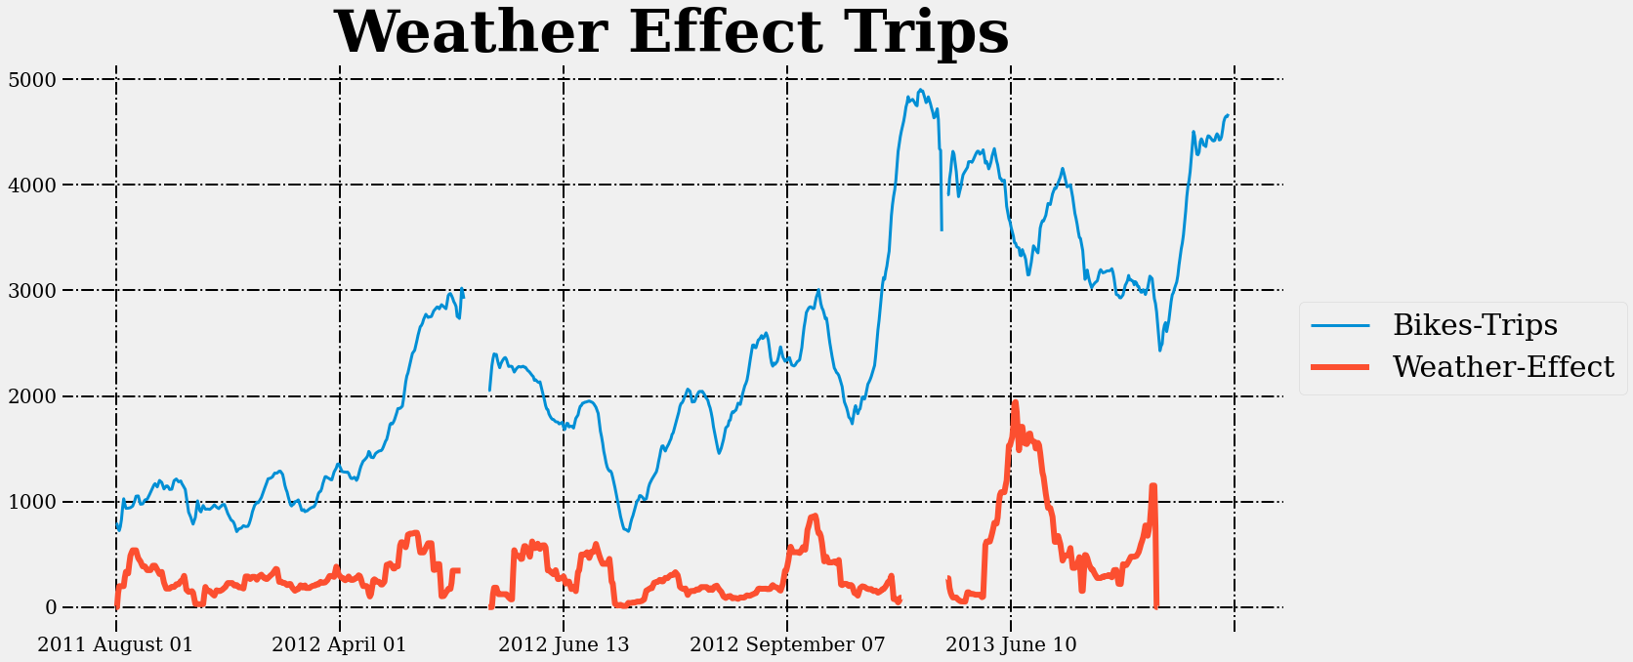

There is a negative correlation between both factors, as precipitation increase one point it lowers trips at ceteris paribus conditions.

In conclusion, Wheelie Wonka shows a positive user experience, increasing the audience six times and not having reasons to concern about the availability of bikes per user.

THANKS, any feedback will be appreciated.

Lorenzo Reyes